DR. AMBEDKAR COLLEGE, DEEKSHABHOOMI NAGPUR

DEPARTMENT OF LAW

NAME OF THE PROGRAM: WEBINAR ON CORPORATE FRAUDS

DATE: 22nd DECEMBER 2022

ORGANISING DEPARTMENT: DEPARTMENT OF LAW

PROGRAM CO-ORDINATOR: DR. PRATIMA LOKHANDE
MS. ANUSHA PATRE

RESOURCE PERSON: MS. PRIYA KUMARI
NUMBER OF STUDENTS: 61
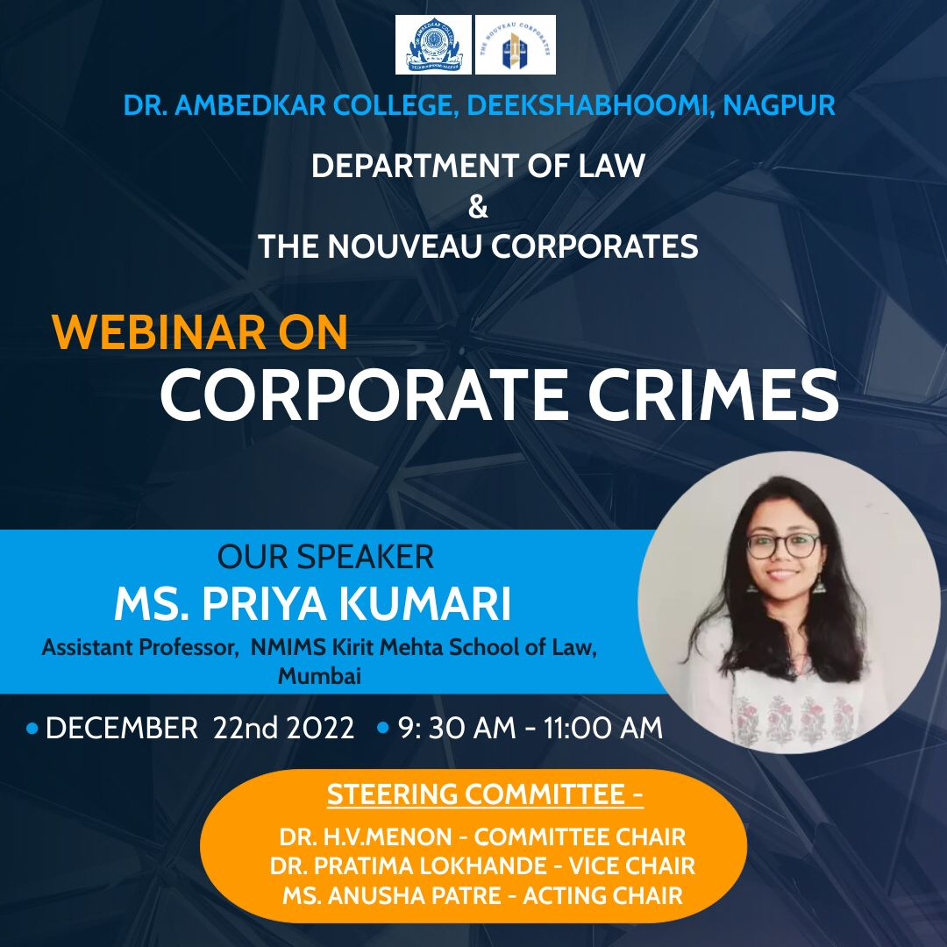

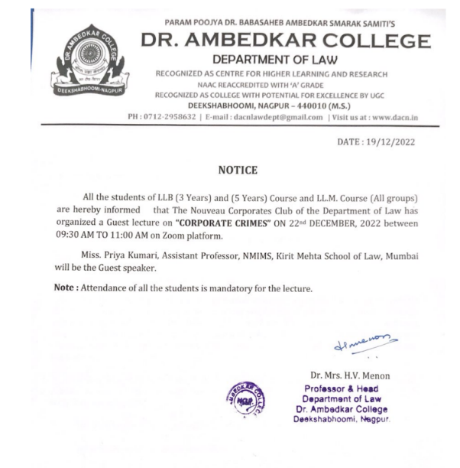
Webinar was conducted for LL.M students and members of The Nouveau Corporates Club on 22/12/2022 on Corporate Crimes. The guest speaker, Ms. Priya Kumari, Assistant Professor in the Faculty of Law, at Kirit P Mehta School of Law, NMIMS Mumbai was welcomed by Dr. Pratima Lokhande (Associate Professor and Vice Chair of the Nouveau Corporates Club, Department of Law DACN).
Ms. Priya Kumari addressed the students by giving an overview about corporate crimes and she briefed the students about the consequences of corporate crimes. Citing Edward Sutherland’s definition on crime Ms. Kumari discussed the various components of corporate crimes from premeditated intent to commit wrongful acts to violation of relationship of trust.
She threw light on the reliance of such crimes on the victims and deviance against the owners, employees, consumers, public etc. and provided an insight into the various Acts like CrPC, IPC and Companies Act that are relevant to the general crimes and corporates crimes by citing examples. The guest speaker also highlighted about the landmark cases likes the satyam scandal, enron debacle etc.
The webinar was followed by a Question Answer session, the guest speaker patiently answered to all the questions which were being asked by the inquisitive minds.
Ms. Anusha Patre, Assistant Professor and Acting Chair of the Nouveau corporates Club moderated the session and Ms. Siddhi Deshpande, Student of LLM III Semester proposed a vote of thanks.
The webinar was a grand success under the able guidance of Dr. Mrs. H.V.Menon, Professor and Head of the Department of Law, Dr. Ambedkar College, Deekshabhoomi, Nagpur.
Over 60 participants attended the webinar.
Some glimpses :
